Spec for quickly extracting overall perimeter, no of apertures/(piercings) and no of bends

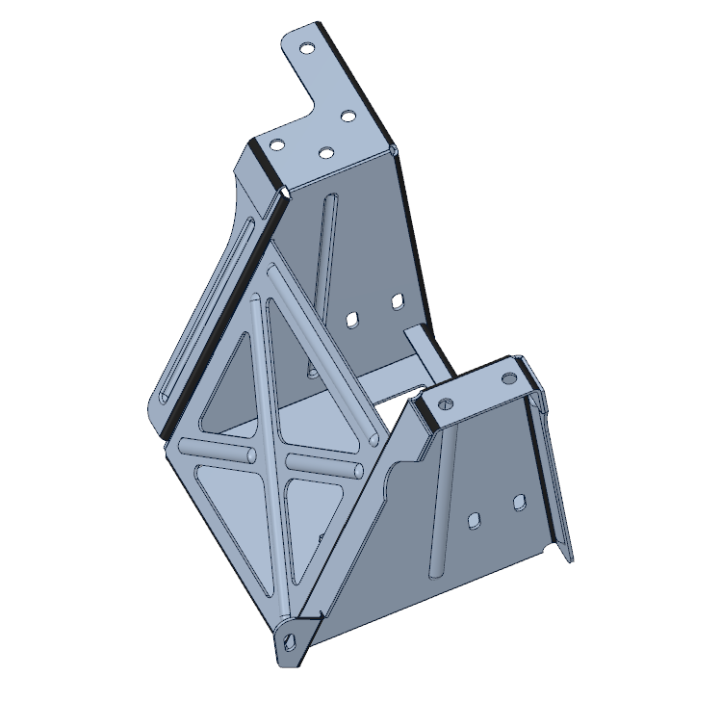Process

1. User opens up a sheetmetal part (see sheetmetal1.scdoc)
2. 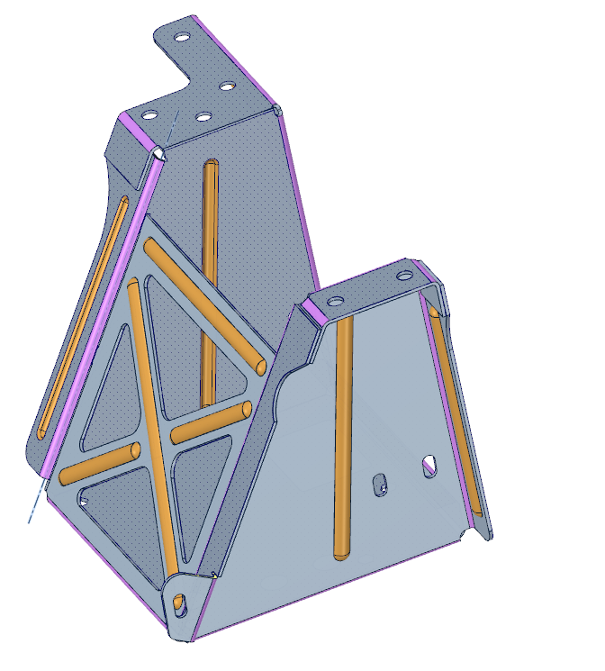User converts to sheetmetal
3. 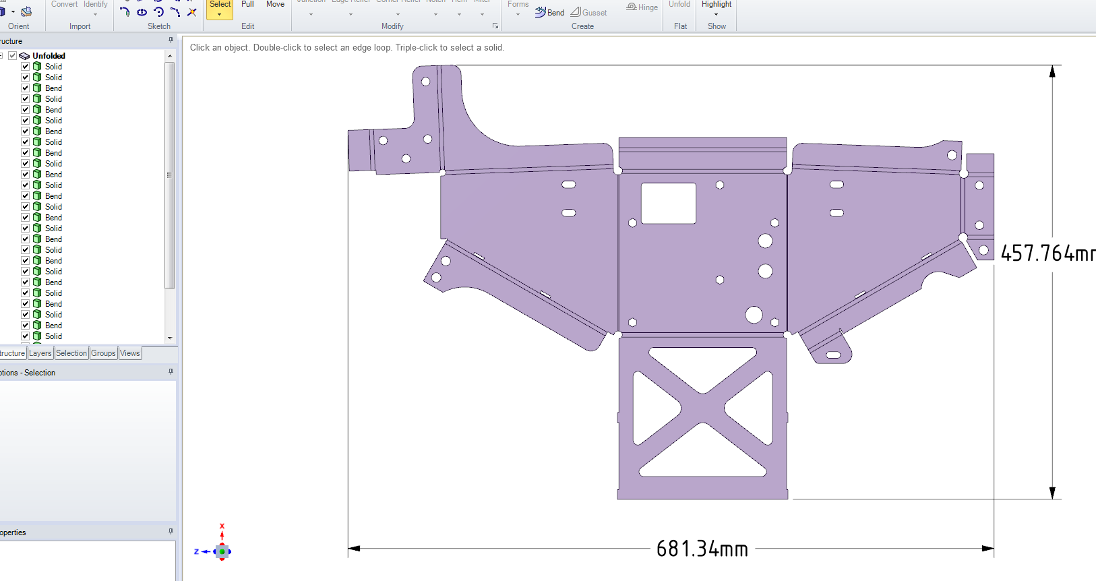User flattens/unfolds it
4. At this point we want a “menu icon/button” and/or right mouse button to “measure – sheetmetal”. The .api app will look at the flat pattern and:-
5. Calculate the overall perimeter – outside profile and all inside profiles
6. Calculate the no of holes/piercings
7. Calculate the no of bends.

This info to be displayed in a table as per the existing measure command. Plus option to export to excel…

Note:- when a part is unfolded it opens up separate design called “unfolded” . This appears to be some kind of locked/restricted format that is tied into the sheet metal part. (see attached sheetmetal1-flat.scdoc - when you open this the flat is in the structure tree and a separate design window

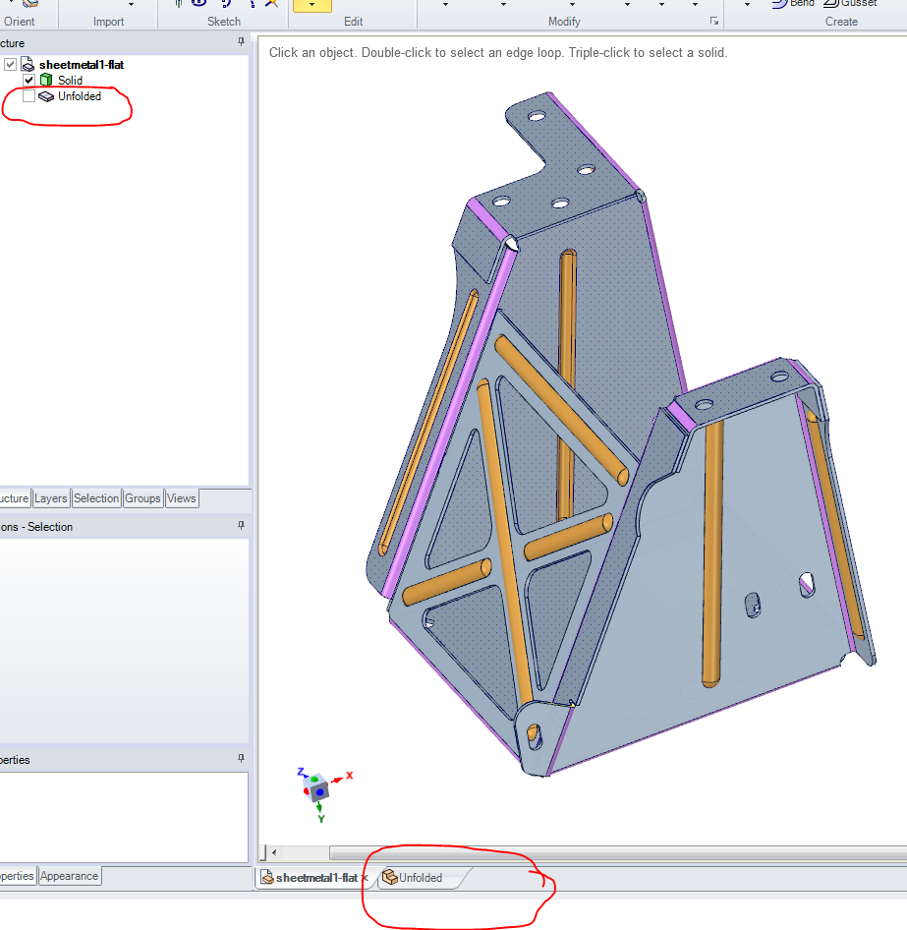

To manually extract the overall perimeter all the solids in the “unfolded” need to be combined.

To combine these you need to:-

1. “select all” the solids – right click “ select> select all” in graphics window
2. 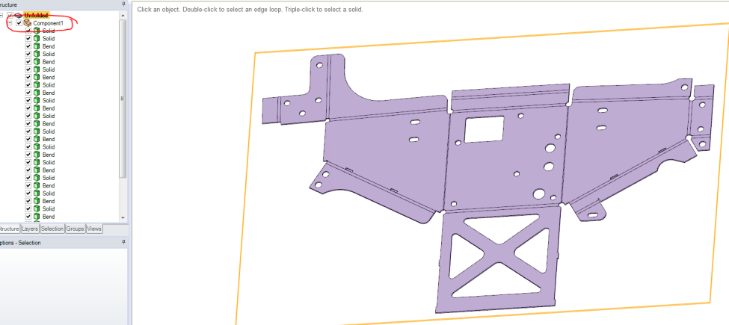right click - “move to new component” – in the structure tree you now have “component 1”
3. This component can then be opened in it’s own “right click – open component”
4. It can now all be combined with the combine tool and measured.

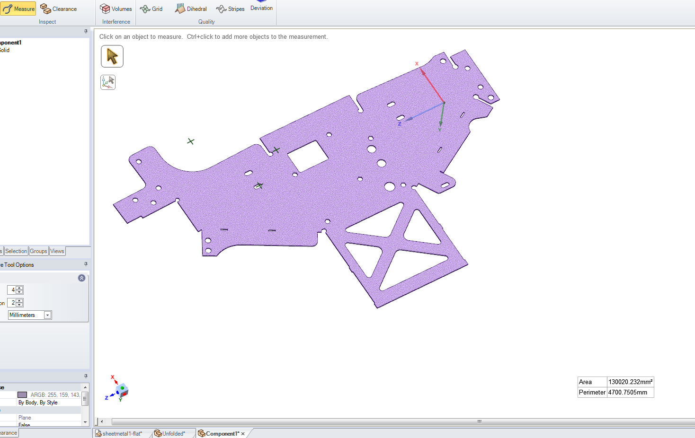

Note: you don’t have to export to a ACIS file as per our web-session.

The above needs to happen automatically –